Kahoot SI

- Conditional independence means:
  - Chain rule
  - Mutually exclusiveness of variables
  - Absence of influence between variables
  - Correlation

- P(A) = ∑P(A,B) calls
  - Bayesian theorem
  - Marginalization
  - Chain rule
  - Joint Probability

- Fundamental rule for Bayesian network is:
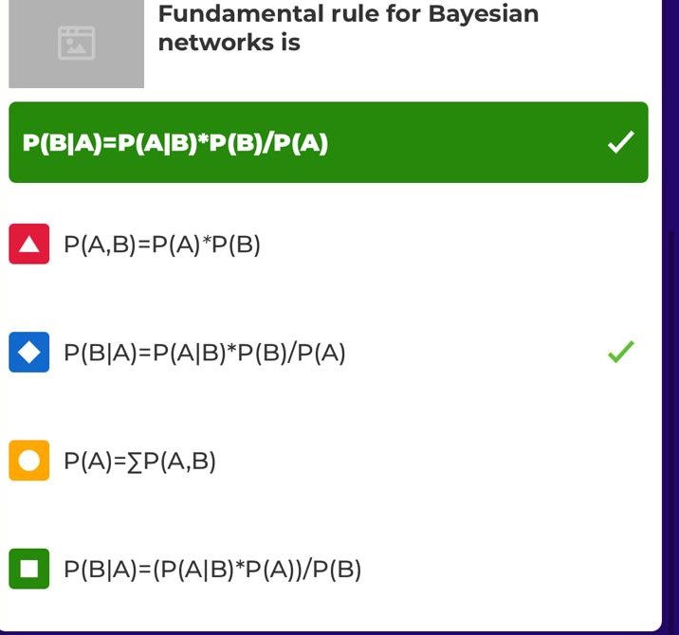
- Markov blanket
  - Node is independent given parents + children + children parents
  - Is equivalent to full joint distribution
  - Node is independent of its nondescendents given its parents

- Noisy -OR assumes
  - All possible causes are listed
  - Independent failure probability for each cause alone
  - None of the above

- Leak node
  - A page in Wikileaks
  - A probabilistic node in a Bayesian net
  - Covers all “miscellaneous causes” in a NOISY-OR relation
  - A node independent of the root of the Bayesian net
- A hybrid Bayesian network
  - Is a bayesian genetically modified by a genetic algorithm
  - Contains both Boolean and non-boolean random variables
  - Contains both discrete and continuous variables
  - Models at least two application domain

- Steps in d-separation algorithms are in the following order
  - Moral graph -> de-orient all arcs -> eliminate evidence -> ancestor graph
  - Ancestor graph -> Moral graph -> remove evidence nodes -> de-orient arcs
  - Moral graph -> ancestor graph -> de-orient all arcs -> eliminate evidence
  - Ancestor graph -> Moral graph -> de-orient all arcs -> remove evidence nodes

Which is not an exact inference algorithm?
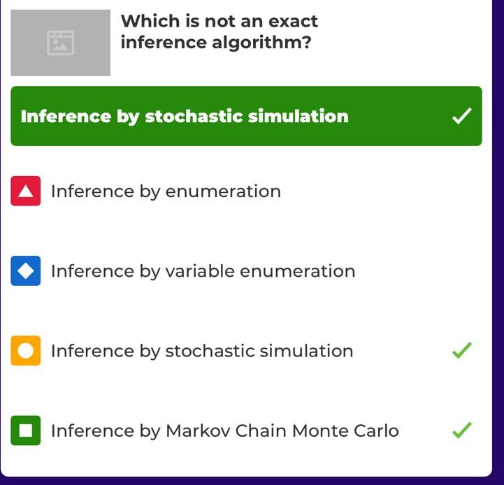

Which are hidden variables for the query P(A|j,m) in the alarm network?


Which are evidence variables for the query P(A|j,m) in the alarm network?

Rejection sampling generates only events that are consistent with the evidence e
MCMC generates samples from scratch
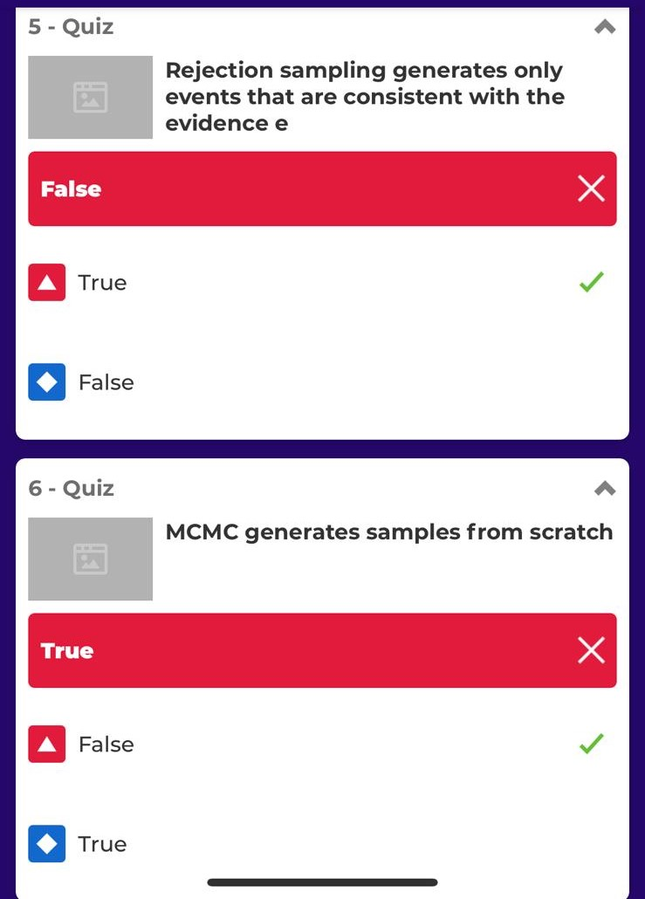

Factors are used in which algorithm?
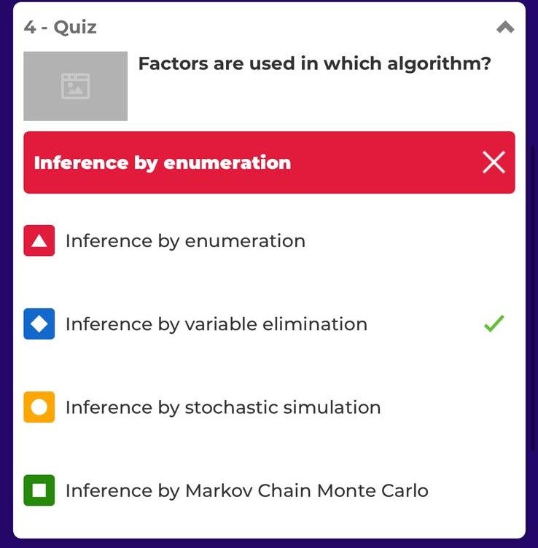

Markov assumption – current state depends on
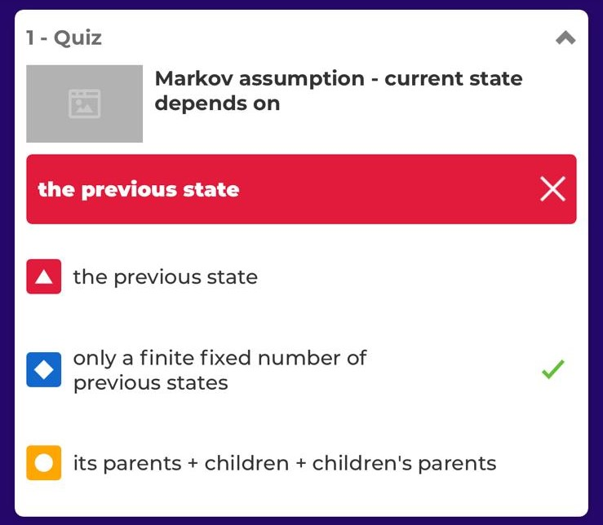

MCMC generates samples from scratch
Likelihood weighting
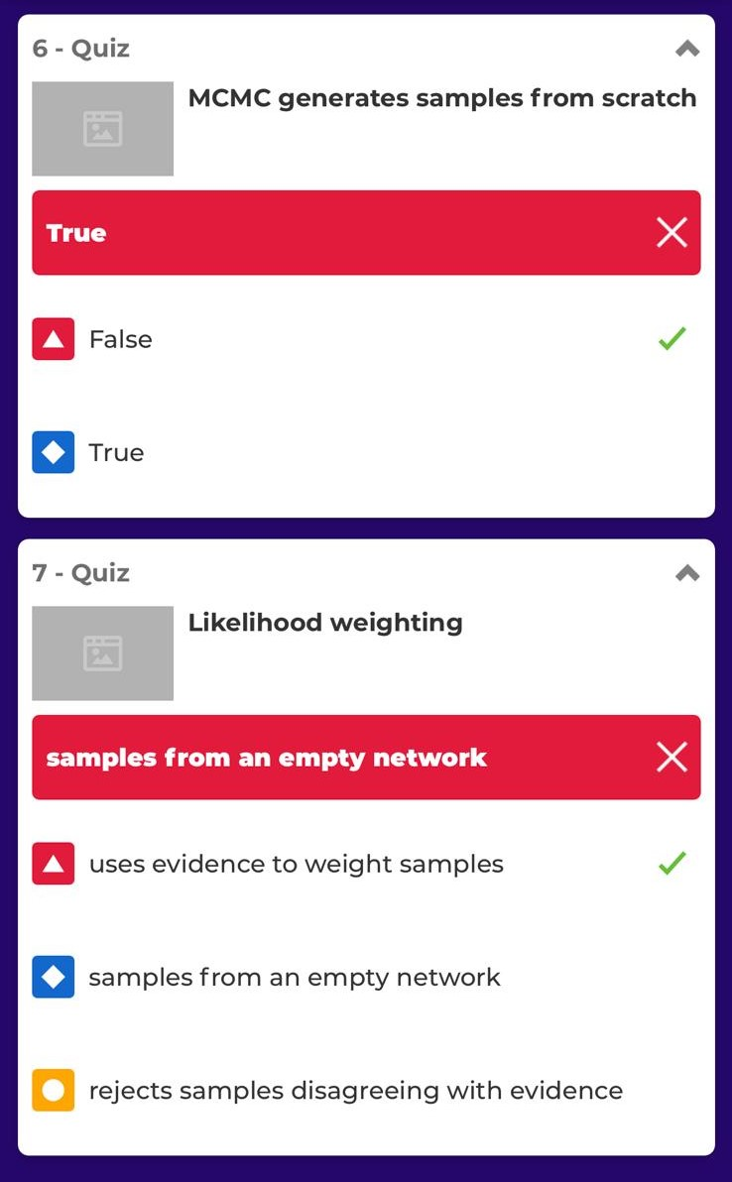

Sensor Markov assumption:

A stationary process
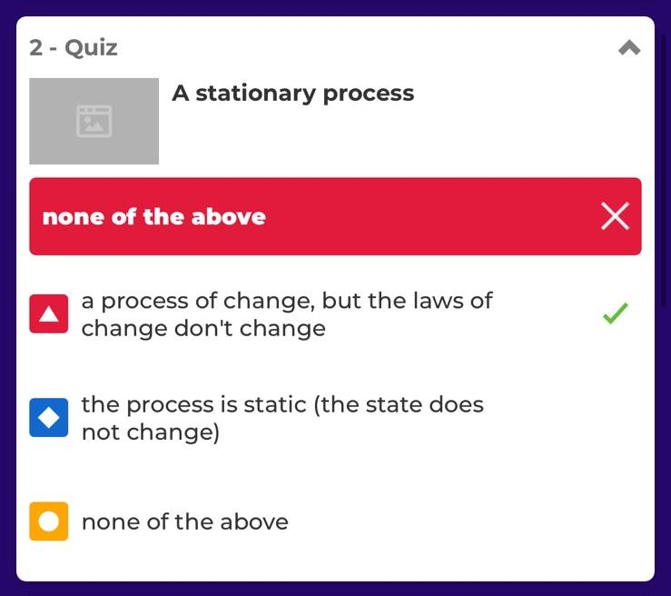
Filtering (state estimation) is

Prediction is


Smoothing is

Finding the most likely explanation

Which is not an inference task in a temporal model?
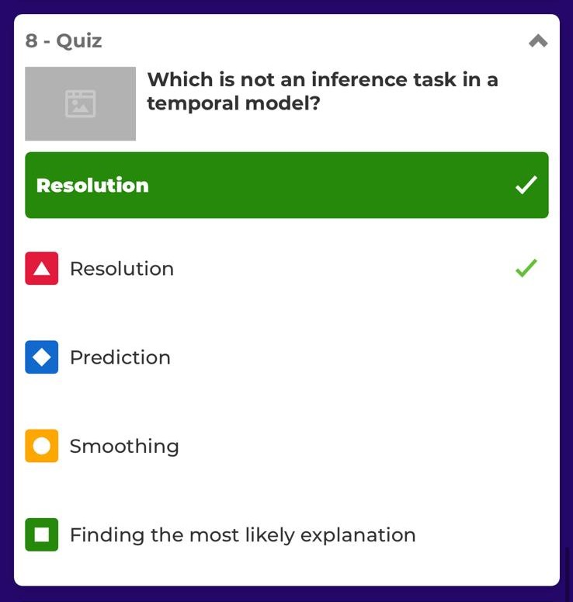
Learning of dynamic Bayesian network means to
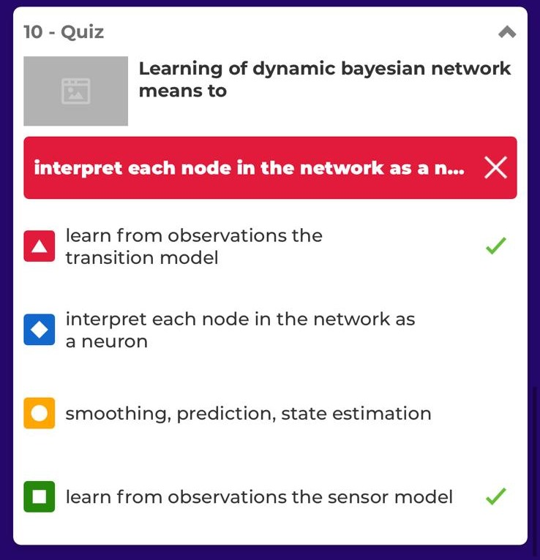
To reason in a dynamic Bayesian network you do not need
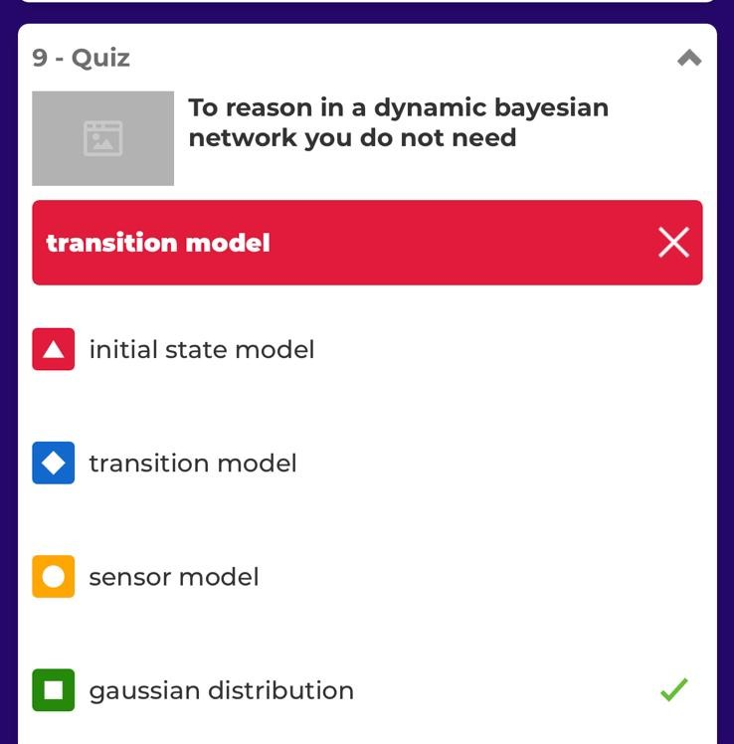
Which is not true about Kalman filtering
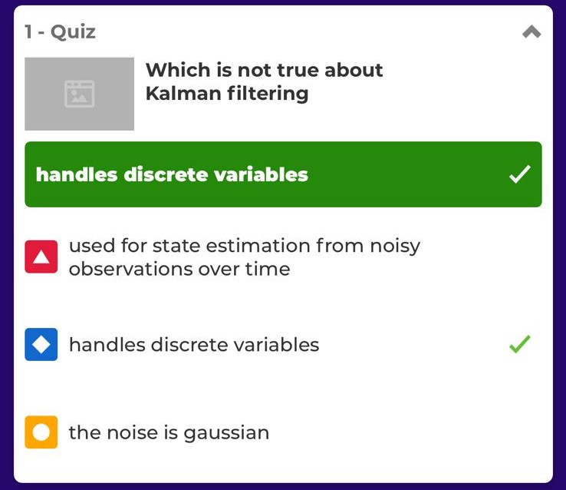

To construct a Dynamic Bayesian Network you do not need
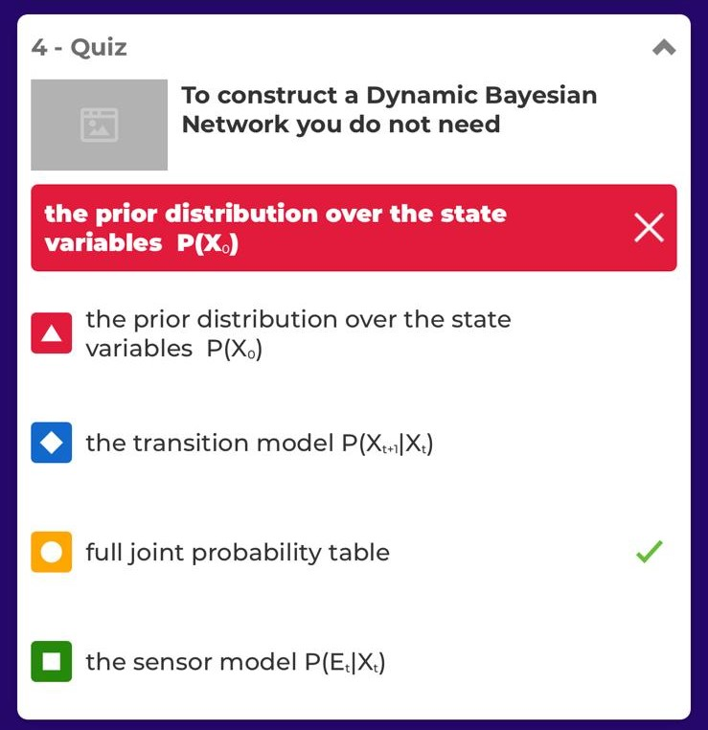

Which is true about basic Kalman filter?
Kalman filter cannot be applied to: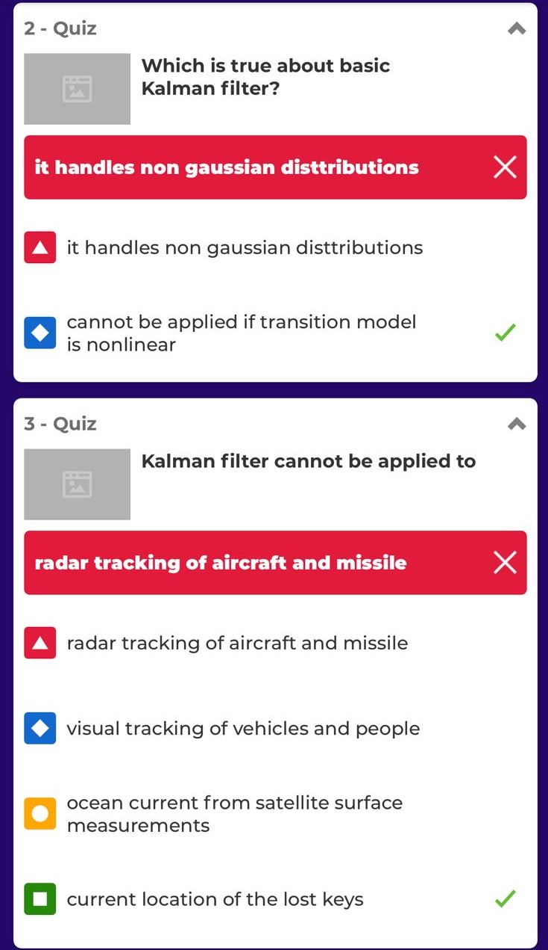
In case of transient failure
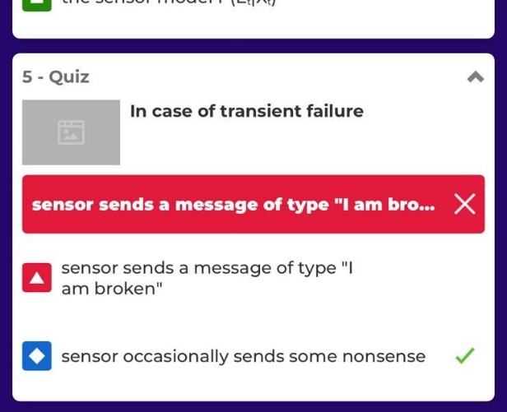
Which is not true about particle filtering? X2
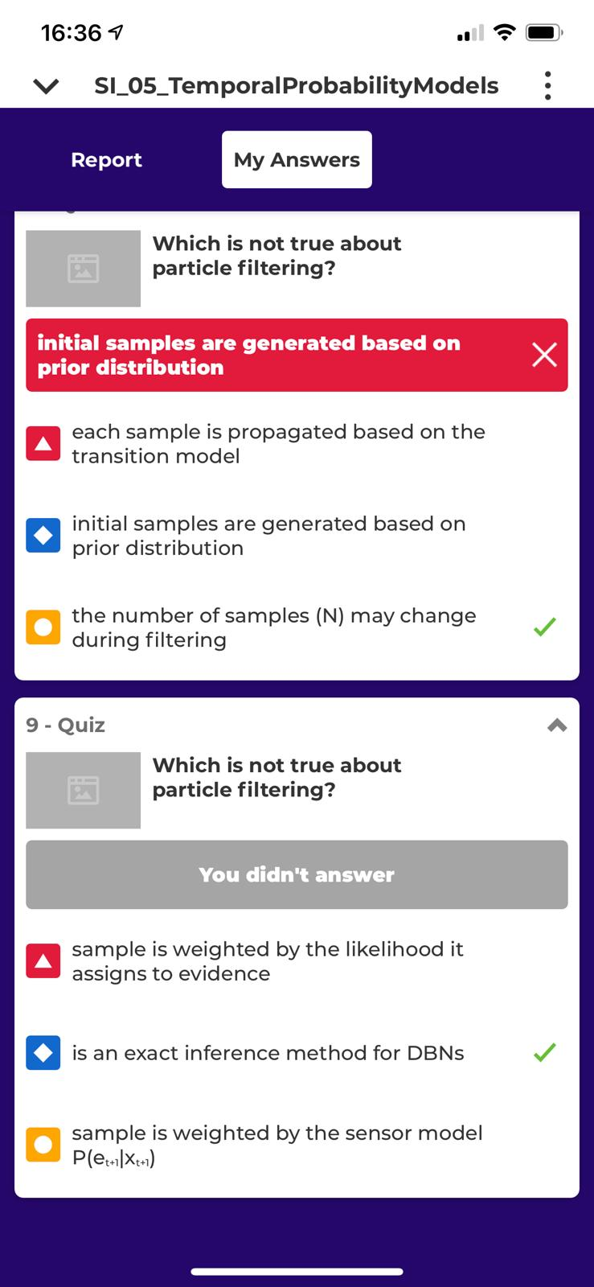
The persistent failure model
The probability P(B_{t-1} | B_{t})=1 in the CTP of the persistence arc says that
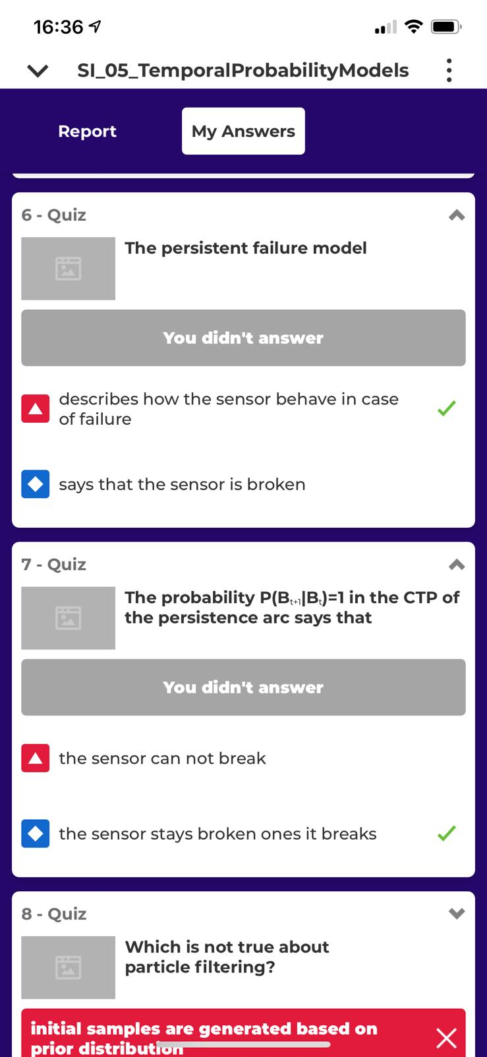

A Markovian decision process is a sequential decision problem for environments
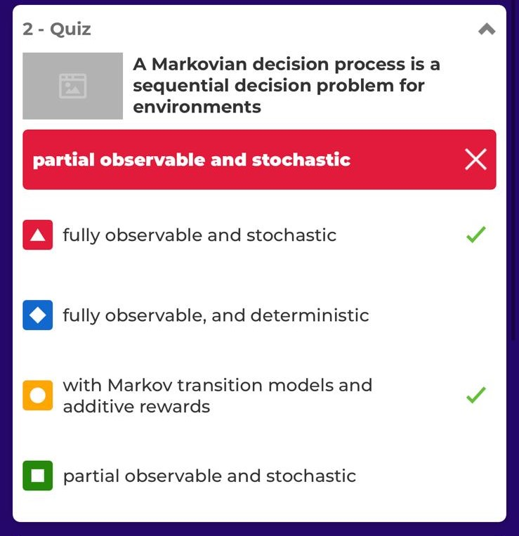
Sequential decision problems (SDP)
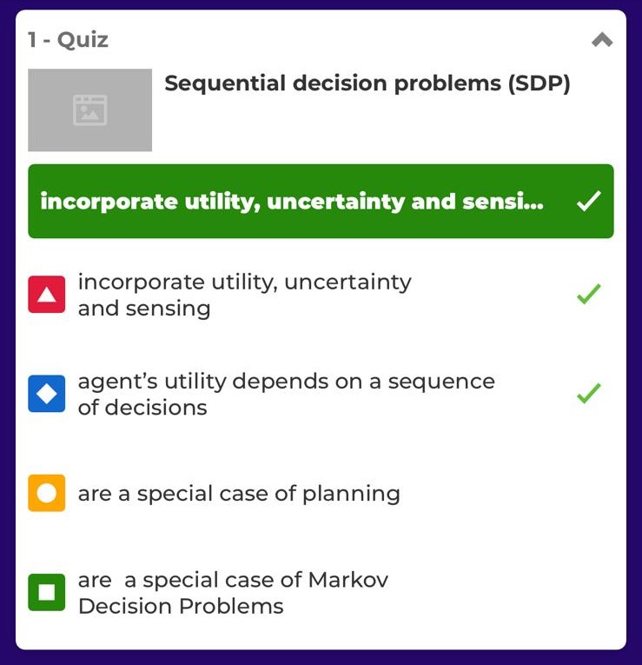

When the discount factor is close to 0, rewards in the distant future are viewed as
Bellman equation
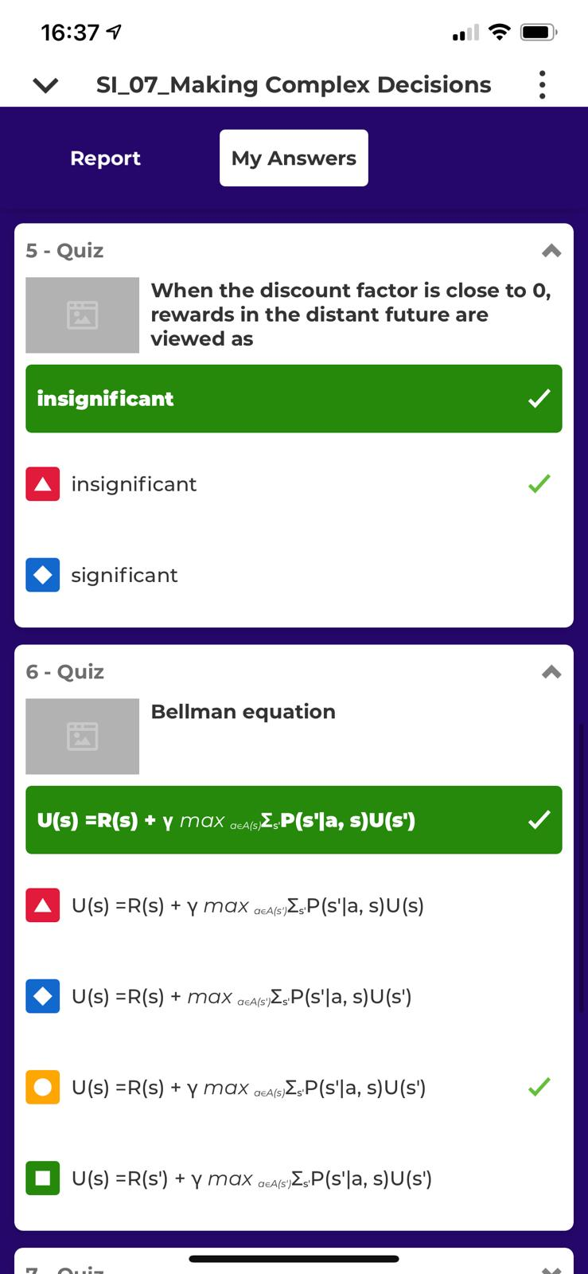
An optimal policy π(s)
An optimal policy for a finite horizon is

Which of the following auctions are public and descending

An outcome is Pareto optimal if
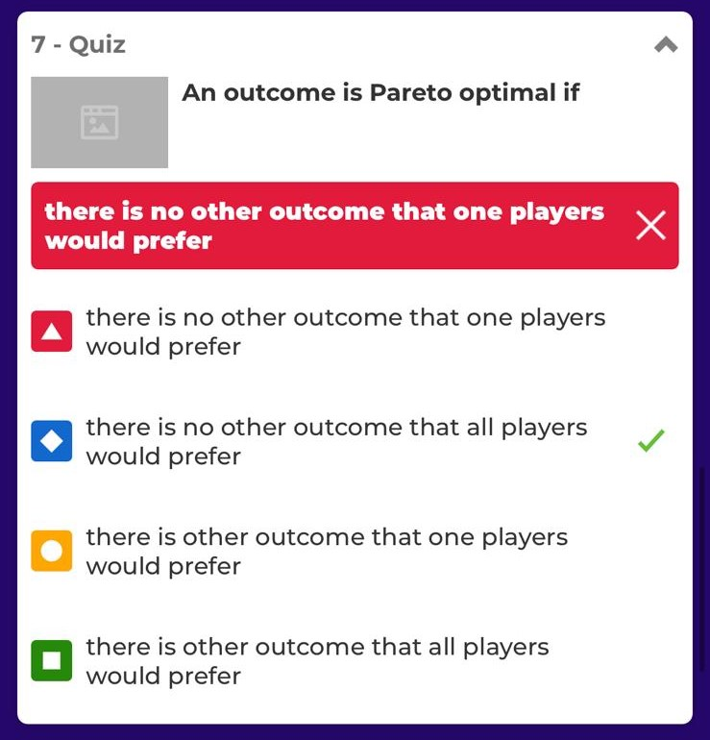
K-means is a
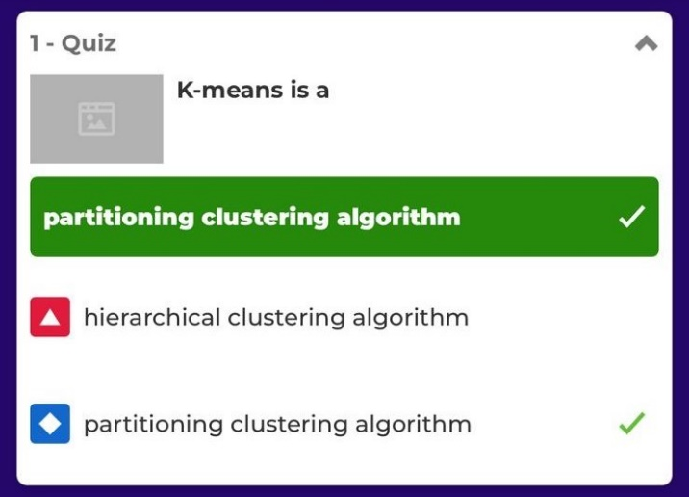
K-means assumes instances x represented as normalized vectors in a real-valued space
In Sum of Squared Error (SSE), for each point
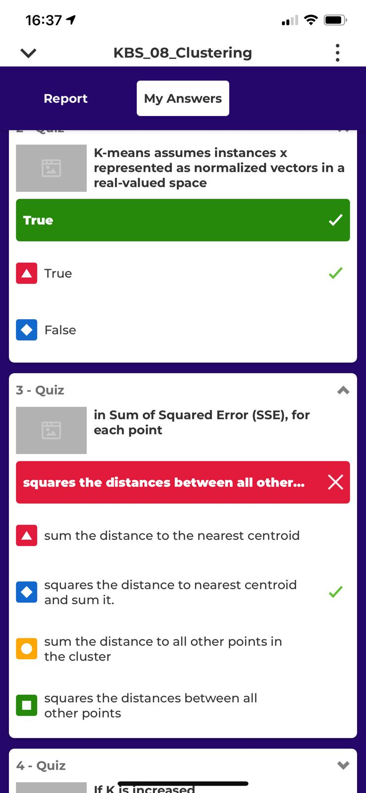
If K is increased
Which is not a solution to initial Centroids Problem
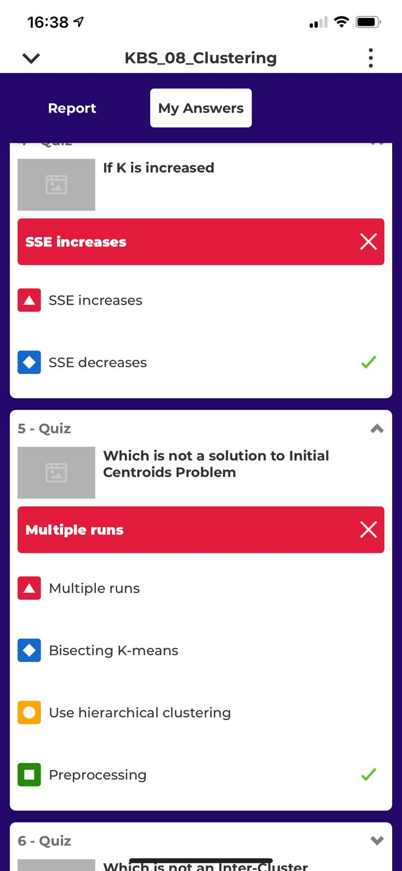

Which clustering technique does not require the user to predetermine the number of clusters?
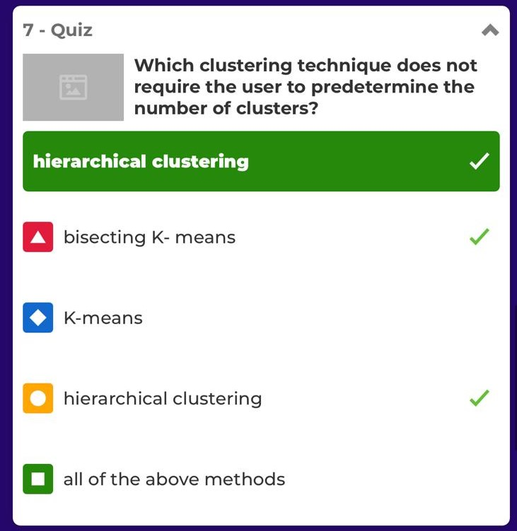
Which is not an Inner-Cluster Similarity metric?
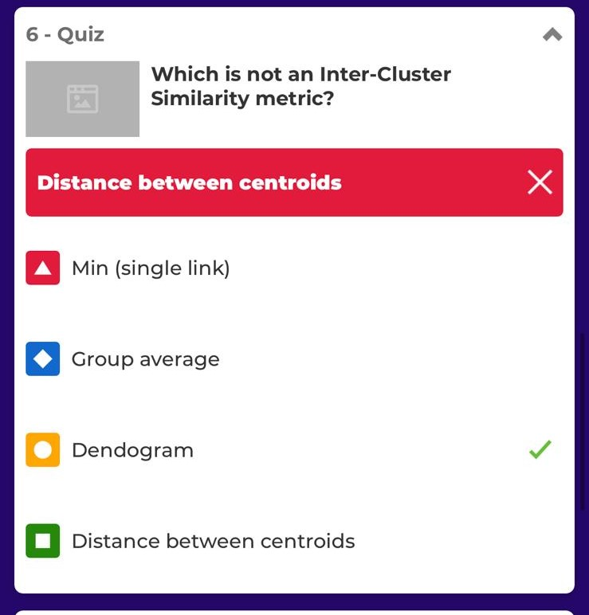

Hierarchical clustering with min (single) link
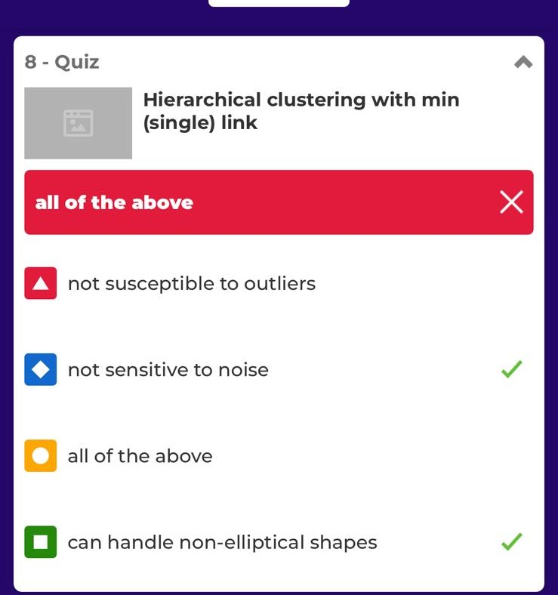
Hierarchical clustering with max (complete) link
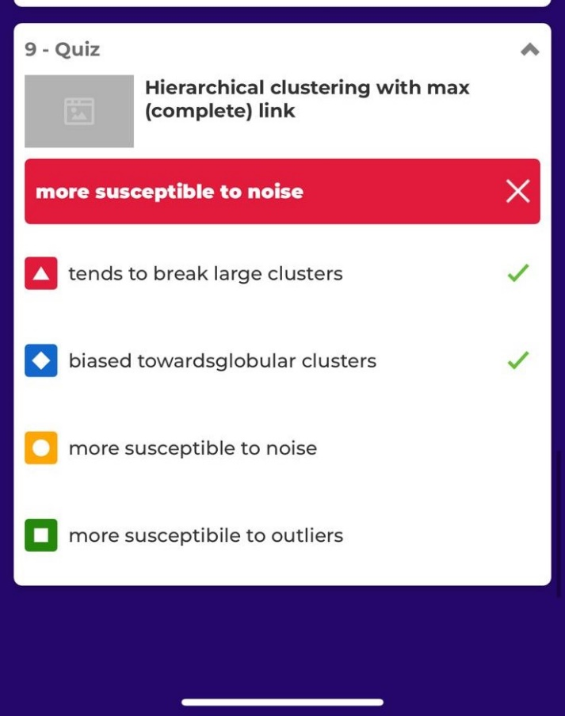
FOIL algorithm avoids overfitting by
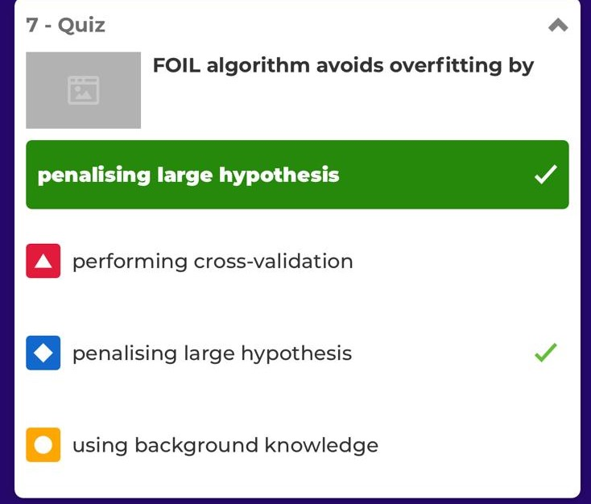
How many rules can be generated with d unique items?

Relevance-based leaning
Which is not true about version spaces?
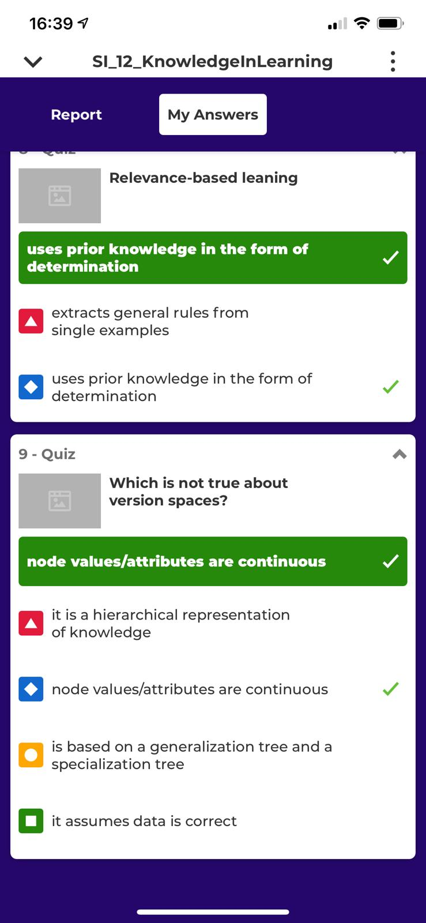

Is confidence a symmetric measure
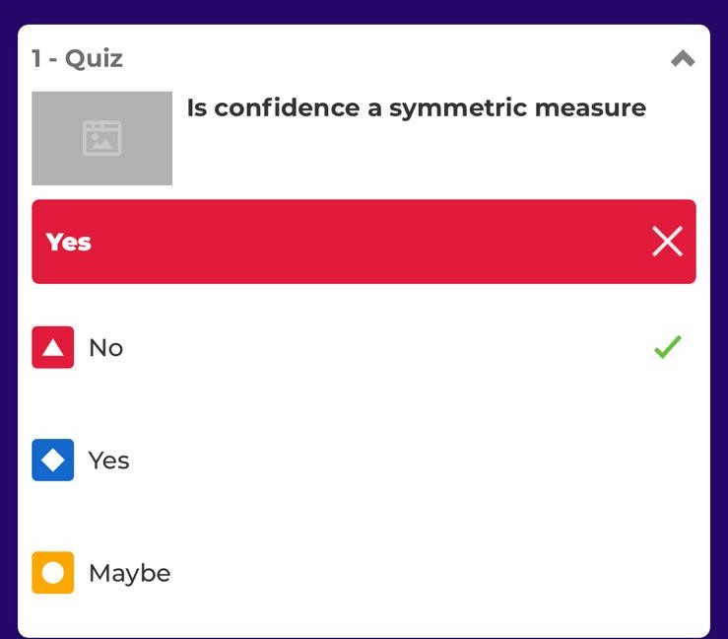
Given d items how many possible candidate itemsets are there?


Oricare ar fi X,Y x inclus in y implica s(X) <= s(Y)
Given a frequent itemset L with |L|=k how many candidate association rules can be generated
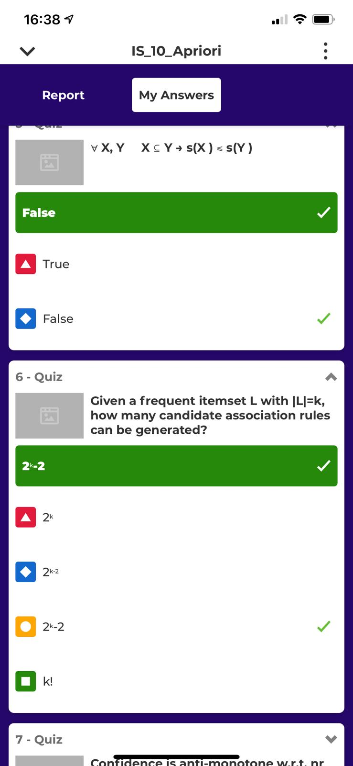
Support of an internet itemset does not exceed the support of its subsets
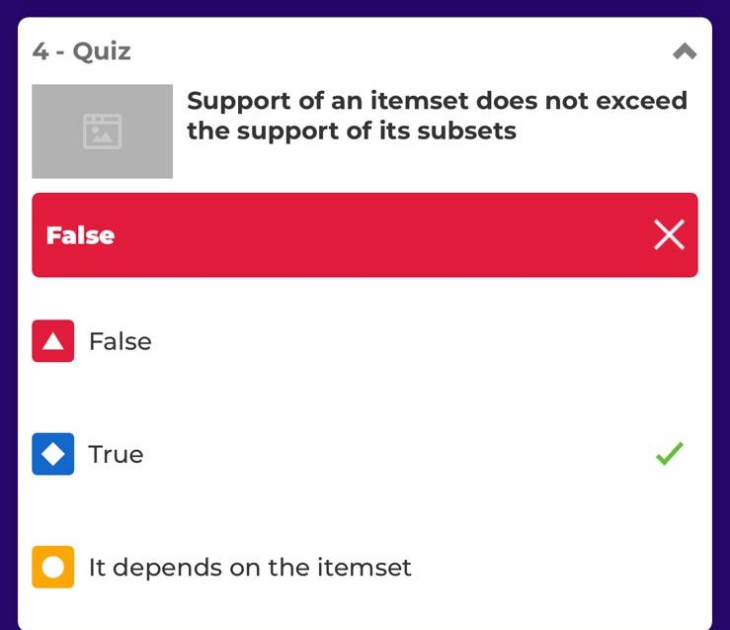
What is the main difference between regression and classification
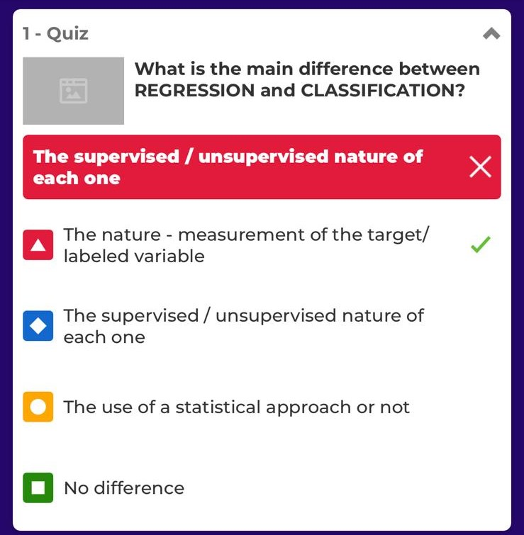
Comfidence is anti-monotone w.r.t. nr of items on the RHS: c(ABC -> D) >= c(AB ->CD) >= c(A->BCD)
F_{k-1} x F_{k} method. Which pair cannot be merged for F3={…}


False positives are solved by
Generalization takes place by
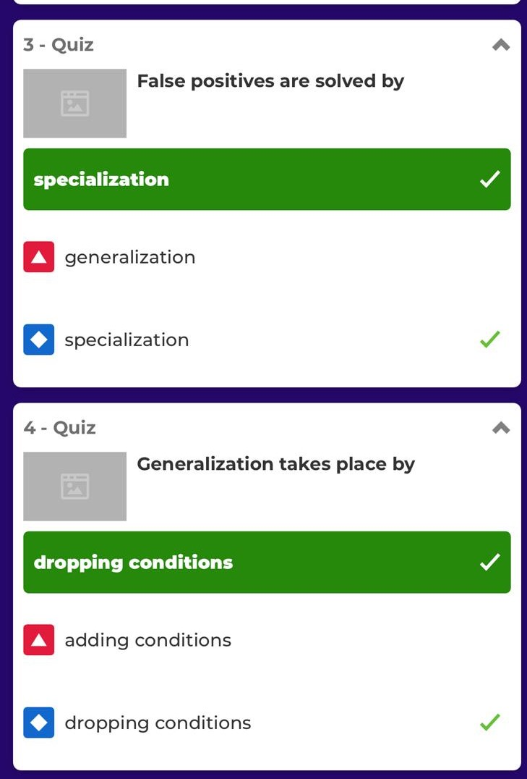

If the hypothesis says that it should be negative but in fact it is positive we have
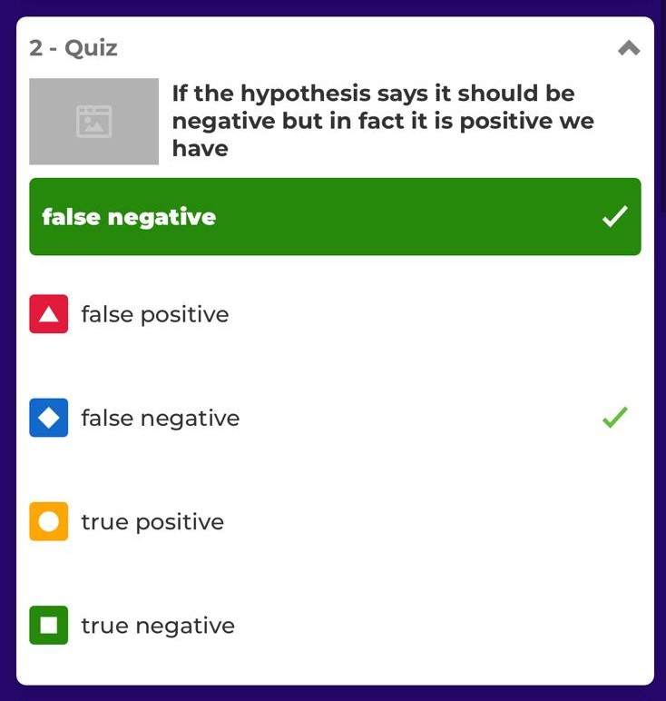
Which is not true about current-best-hypothesis search method?
